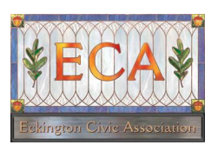

Eckington Civic Association Meeting
Monday, October 3, 2016, 7:00pm
The Summit at St. Martin’s, 116 T Street NE

1. President and Committee Reports

2. Reports from Elected Officials.

3. Questions for ANC Candidates

At the meeting will assemble a list of questions from the community for the ANC 5E candidates representing Eckington. If you would like to send us some questions in advance, please complete the survey here: https://docs.google.com/forms/d/e/1FAIpQLSf24WJW64tL_xPERgdayAJvzodSvmnIvoleR4YAqYIatz85vQ/viewform

4. Request for Support - BZA Case no. 19302
232 S St NE - conversion to 3 units
See attached report from the Office of Planning.

Next ECA Meeting: Monday, November 7th

Follow us on Twitter @Eckingtoncivic │ Email us at EckingtonCivic@gmail.com
Look us up on https://eckingtoncivicassociation.org/ │ Find us on Facebook: Eckington Civic Association

